**---- Global Oil price; Oil Supply Availability and Electricity Price are key effecting factors on EV charging markets (green)-----**

**Energy**

Energy price, energy security and supply sustainability always has been the main concern for governments in regard to transportation sector. In this section we will analysis the role of energy in development of EV charging market.

**Global Oil Price**

Global oil price has direct effect on electric vehicle market. Cheaper oil price can reduce the demand for electric vehicles, as well as higher oil price can boost electric vehicle market and motivate consumer to purchase electric vehicles.

There are lots of argue about recent oil price fall and its effect on Electric vehicle market growth, but the point is how long will cheap oil continue?

According to the Commodity Forecast released by The World Bank in January 2015, that world crude oil price will see an smooth increase from $53.2/barrel in 2015 to around $103.4/barrel in 2025.

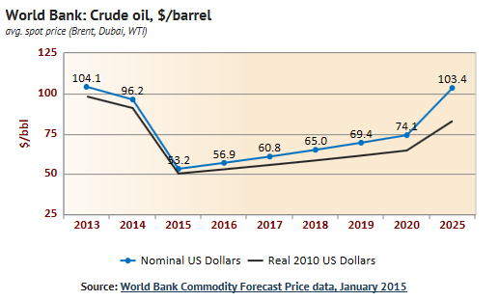

.

---Oil price will see an smooth increase from $53.2/barrel in 2015 to around $103.4/barrel in 2025 (gray)----

as can be seen , short term oil price by falling from $104/barrel in 2013 to $53.2/barrel in 2015 maybe has slowed down the electric market growth, but from a long term view oil price growth will motivate more and more consumers to buy electric vehicle and save money on oil price.

**Oil supply availability**

Crude oil is the lifeblood in modern world, Politicians always concern about sustainable access to crude oil to secure their energy supply network system. But the key question is: can we have unlimited access to crude oil forever?

According to current research, tow third of oil remaining reserves are in the Middle East.

--- There are an estimated 1.3 trillion barrels of proven oil reserve left in Middle East (Gray)----

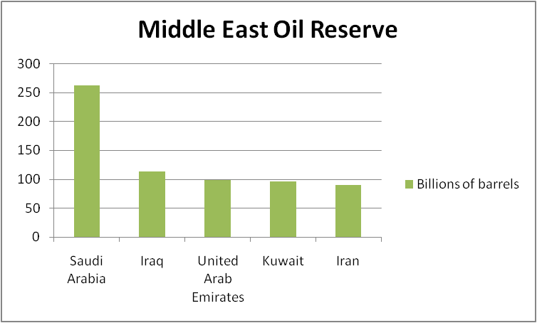

As can be seen, There are an estimated 1.3 trillion barrels of proven oil reserve left in the world’s major fields, which at present rates of consumption will be sufficient to last 40 years.

By 2040, production levels may be down to 15 million barrels per day – around 20% of what we currently consume. It is likely by then that the world’s population will be twice as large, and more of it industrialized.

Therefore, Electric vehicle seems to be a good substitute for internal combustion engine cars to decrease the dependence of transportation system on crude oil.

**Electricity price**

Electricity price also play a significant role in development of EV charging market. As different countries produce electricity from different resources and apply different subsidy policy , the electricity prices are very variable all around the world.

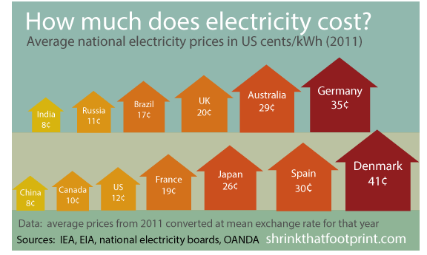

Most of the potential electric vehicle purchasers take the electricity price into account during EV purchasing decision making process. Governments need to provide more subsidies on electricity price in order to encourage more consumers to purchase and use electric vehicles.

**Green Energy Vs. Brown Energy**

Electric plants produce electricity from two major resources; one is Green energy resources which refers to environment friendly resources look like solar power and wind. The other type is brown energy resource which refers to environment unfriendly resources look like coal and fossil fuel.

Green energy is more expensive than brown energy due to rare energy resources and more complicated equipment and production process which is needed during energy production.

For example China mainly rely on coal for electricity production, it cause a serious environment pollution which can neutral the effect of electric vehicle in reducing air pollution.

Therefore, while governments encourage consumers to purchase electric vehicles, they also should invest more in the field of green energy to make sure the electric vehicles can make their positive contribution to the environment.